Course: ENCS304 – Computer Networks
Name: Anant Soni
Roll Number: 2301730095
Program: B.Tech CSE (AI & ML)

Task 1: Star Topology (Switch-Based)
Configuration:
• 1 Switch connected to 4 PCs
• IP Range: 192.168.10.1 – 192.168.10.4
• Subnet Mask: 255.255.255.0

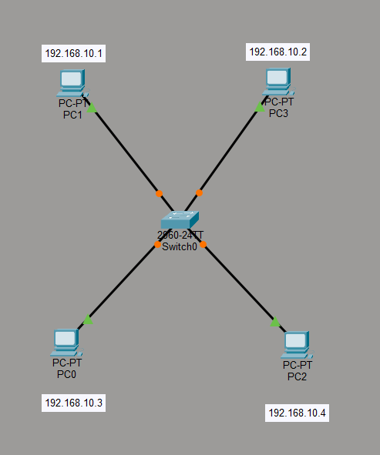

Testing:
• Ping from PC1 to PC2, PC3, and PC4
Result:
• All pings successful (0% packet loss)
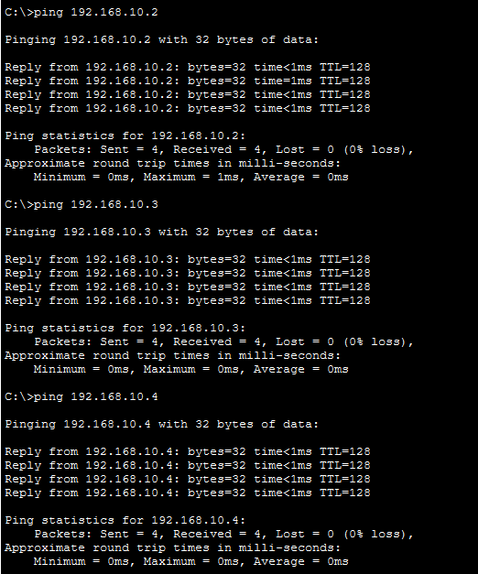
Observations:
• Switch forwards frames only to destination port
• Reduced congestion compared to hub
• If one PC fails, others remain unaffected

